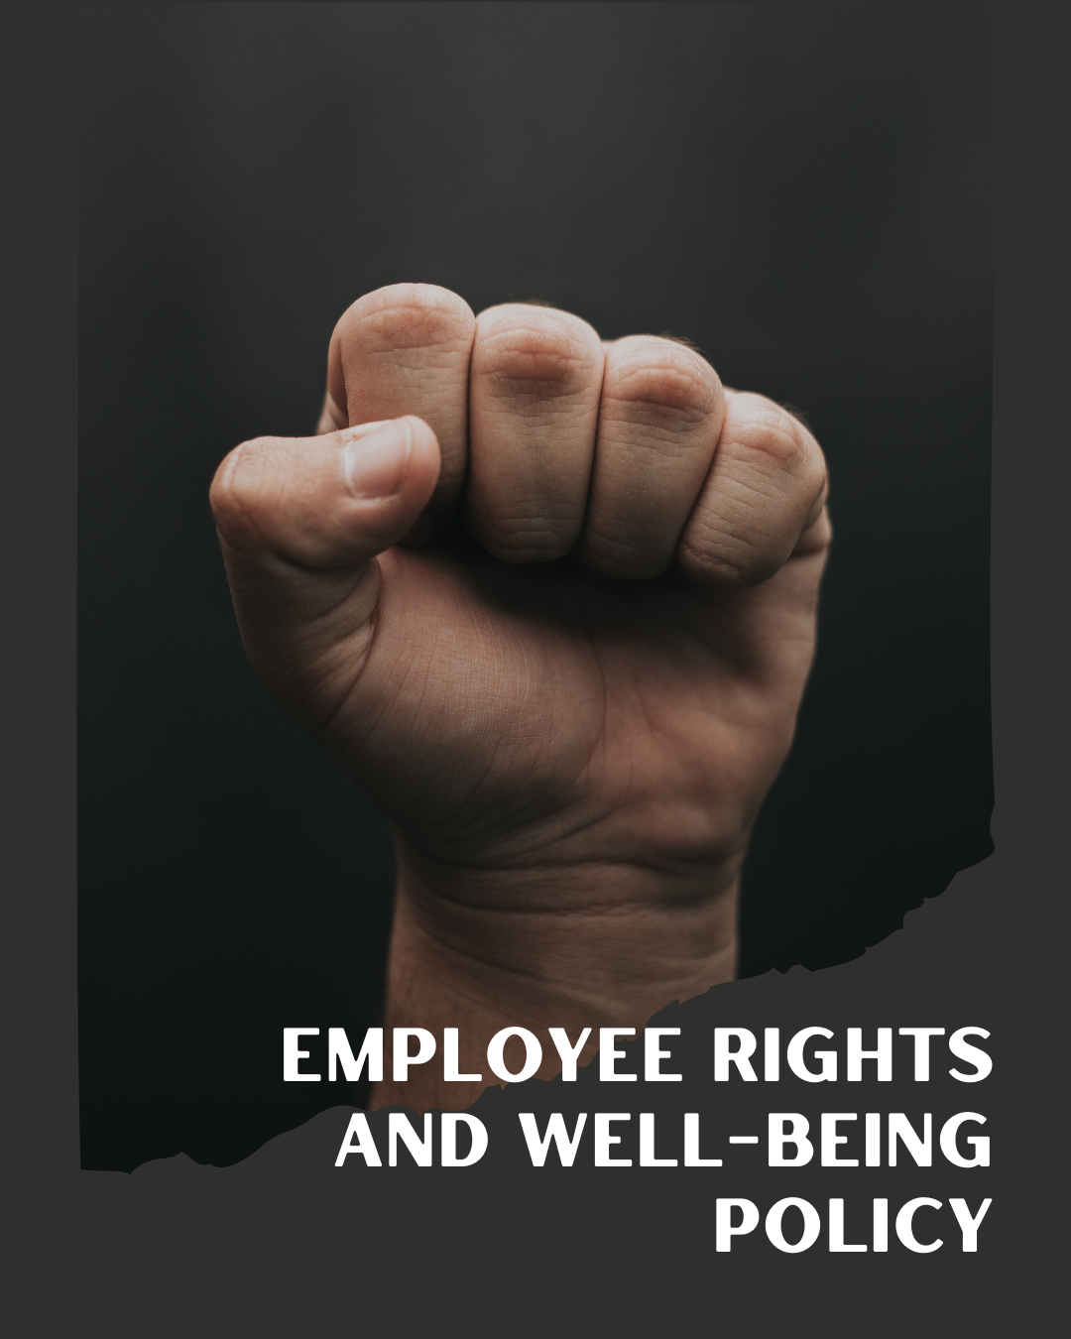
ARSH FASHIONS PVT. LTD.

A UNIT OF PERMESHWAR FASHIONS IMPEX PVT. LTD.

TABLE OF CONTENTS
PREFACE 2
SCOPE 2
POLICY DECLARATION 2
INITIATIVES AND TARGETS IN ALIGNMENT WITH SDGs 3
PERFORMANCE REPORTING 4
REVIEW MECHANISM 4

PREFACE

At Arsh Fashions, we prioritize the rights and well-being of every employee, recognizing that their welfare is crucial to our success. Our Employee Rights and Well-Being Policy is designed to ensure a safe, equitable, and supportive work environment. We are committed to upholding fair labour practices, providing adequate compensation, and maintaining safe working conditions in alignment with global standards.

This policy outlines our dedication to respecting and protecting employee rights while fostering a culture of mutual respect and support. By promoting well-being and addressing concerns proactively, we aim to empower our team and drive positive, sustainable growth within our organization.

SCOPE

This Policy is applicable to following sites and all of its employees, workers, sub-contractors and other stakeholders:

Sr. No. | Site | Address
1 | ARSH FASHOINS Pvt. Ltd. | Plot No.194, IInd Phase, G.I.D.C., Vapi - 396195,  Gujarat, India.

POLICY DECLARATION

Arsh Fashions is committed to protecting employee rights and ensuring a safe, fair, and supportive work environment. We adhere to all labor laws and international standards, providing equitable compensation and addressing workplace safety. Our policy promotes respect, inclusivity, and continuous improvement for employee well-being. Our baseline year is 2023, for setting the reference framework for evaluating progress, compliance, and improvements in our employee rights and well-being practices.

INITIATIVES AND TARGETS IN ALIGNMENT WITH SDGs
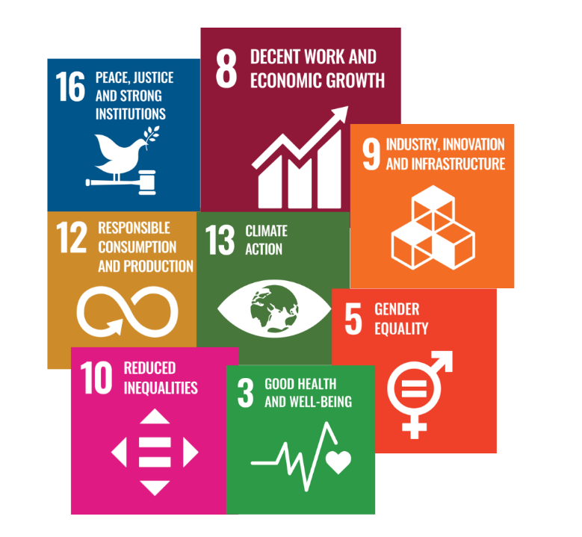

- Foster a culture of proactive safety awareness and continuous improvement.
- Ensure 100% of employees complete mandatory safety training within the first month of employment
- Provide transparent communication about compensation and benefits policies.
- Offer a benefits package that includes at least 95% of standard industry benefits, such as health insurance, retirement plans, and paid leave by year 2030
- Maintain a clean, ergonomic, and well-lit work environment and regularly engage employees in feedback about their working conditions.
- Educate employees on water conservation techniques and the importance of reducing water usage in manufacturing.
- Achieve a 90% satisfaction rate in annual employee surveys regarding working conditions by year 2030.
- Build strong, transparent communication channels between management and staff and resolve conflicts and grievances efficiently and fairly.
- Conduct regular biannual surveys to measure employee satisfaction with management’s handling of labor relations and achieve 90% employee satisfaction by year 2030.
- Educate suppliers and partners to implement strict policies and audits to prevent child and forced labor.
- Achieve 100% compliance with child and forced labor regulations in all supply chains by year 2030
- Create an inclusive environment where all employees feel valued and respected and develop programs to promote understanding and address biases.
- Increase representation of underrepresented groups by 15% by year 2030.
- Ensure transparency and ethical practices in all external relationships.
- Achieve a 100% response rate to human rights inquiries from stakeholders by year 2030.
- Promote a flexible work environment that supports employees’ personal needs.
- Provide resources and programs that help employees manage work-life balance effectively.

PERFORMANCE REPORTING

The Performance reporting will be conducted annually, encompassing a comprehensive review of compliance with labor rights regulations, the impact and reach of employee well-being initiatives, and the effectiveness of training and development programs. It will provide an in-depth analysis of grievance resolution processes, results from human rights impact assessments, and advancements in ethical supply chain practices. Additionally, the report will evaluate employee engagement and satisfaction metrics, alongside the efficacy and reach of compliance training programs.

REVIEW MECHANISM

The Employee Rights and Well-Being Policy will undergo an annual review conducted by the HR Manager to ensure it meets compliance and transparency standards. The review will include a thorough analysis of policy implementation, effectiveness, and any emerging issues or trends. Additionally, stakeholder feedback will be incorporated to refine the policy, with final updates.

REV. No. 01

EFFECTIVE FROM: 01.01.2024 NEXT REVIEW DATE: 01.01.2025

APPROVED BY: PRESIDENT - OPERATIONS

